A Project report on

Career Guidance System For Students Using Machine Learning Based Skill and Interest Analysis

A Dissertation Submitted to JNTUH, Hyderabad in Partial Fulfillment of the Academic Requirements for the Award of the Degree.

Bachelor of Technology
in
Computer Science and Engineering (AI&ML)
Submitted by

- YUVA VENKAT
22H51A6603
- JAYANTH KUMAR
22H51A6645
- VAISHNAVI
23H55A6609

Under the esteemed guidance of
Mrs. K. Anusha
(Assistant Professor)


Department of Computer Science and Engineering (AI&ML)

CMR COLLEGE OF ENGINEERING & TECHNOLOGY

(UGC Autonomous)
*Approved by AICTE *Affiliated to JNTUH *NAAC Accredited with A⁺ Grade

KANDLAKOYA, MEDCHAL ROAD, HYDERABAD - 501401.

2025-2026

.
CMR COLLEGE OF ENGINEERING & TECHNOLOGY
KANDLAKOYA, MEDCHAL ROAD, HYDERABAD – 501401

DEPARTMENT OF COMPUTER SCIENCE and ENGINEERING (AI&ML)


CERTIFICATE

This is to certify that the Major Project report entitled "Career Guidance System For Students Using Machine Learning Based Skill and Interest Analysis" being submitted by A. Yuva Venkat (22H51A6603), P. Jayanth Kumar (22H51A6645), G. Vaishnavi (23H55A6609) in partial fulfillment for the award of Bachelor of Technology in Computer Science and Engineering (AI&ML) is a record of bonafide work carried out his/her under my guidance and supervision.

The results embodies in this project report have not been submitted to any other University or Institute for the award of any Degree.

Mrs. K. Anusha Dr. S. Kirubakaran
Assistant Professor Professor and HOD
Dept. of CSE (AI&ML) Dept. of CSE (AI&ML) EXTERNAL EXAMINER

ACKNOWLEDGEMENT

With great pleasure we want to take this opportunity to express my heartfelt gratitude to all the people who helped in making this project work a grand success.
We are grateful to Mrs. K. Anusha, Assistant Professor, Department of Computer Science and Engineering (AI&ML) for his valuable technical suggestions and guidance during the execution of this project work.
We would like to thank Dr. S. Kirubakaran, Professor, Head of the Department of Computer Science and Engineering (AI&ML), CMR College of Engineering and Technology, who is the major driving forces to complete my project work successfully.
We are very grateful to Dr. Ghanta Devadasu, Professor, Dean-Academics, CMR College of Engineering and Technology, for his constant support and motivation in carrying out the project work successfully.
We would like to thank Dr. A. Seshu kumar, Professor, Principal, CMR College of Engineering and Technology, for his support was invaluable to the project's success.
We are highly indebted to Dr. V A Narayana, Professor, Director, CMR College of Engineering and Technology, for giving permission to carry out this project in a successful and fruitful way.
We would like to thank the Teaching & Non- teaching staff of Department of Computer Science and Engineering for their co-operation
We express our sincere thanks to Shri. Ch. Gopal Reddy, Secretary& Correspondent, CMR Group of Institutions, and Shri Ch Abhinav Reddy, CEO, CMR Group of Institutions for their continuous care and support
Finally, We extend thanks to our parents who stood behind us at different stages of this Project. We sincerely acknowledge and thank all those who gave support directly and indirectly in completion of this project work.

A. Yuva Venkat 22H51A6603
P. Jayanth Kumar 22H51A6645
G. Vaishnavi 23H55A6609

Career Guidance System For Students Using Machine Learning Based Skill And Interest Analysis

TABLE OF CONTENTS

CHAPTER
NO. TITLE PAGE NO.
LIST OF FIGURES iii
LIST OF TABLES iv
ABSTRACT v
1 INTRODUCTION 1-2
1.1 Problem Statement 3
1.2 Research Objective 3
1.3 Project Scope 4
2 BACKGROUND WORK 5
2.1. Traditional Career Counselling Centers 6
2.1.1. Introduction 6
2.1.2. Merits, Demerits and Challenges 6
2.1.3.Implementation of Traditional Career Counselling Centers 7
2.2. Online Career Assessment Tools 10
2.2.1. Introduction 10
2.2.2. Merits,Demerits and Challenges 10
2.2.3.Implementation of Online Career Assessment Tools 11
2.3. AI - Based Career Platforms 15
2.3.1.Introduction 15
2.3.2.Merits,Demerits and Challenges 15
2.3.3.Implementation of AI - Based Career Platforms 16
3 PROPOSED SYSTEM 20
3.1. Objective of Proposed Model 21
3.2. Algorithms Used for Proposed Model 22
3.3. Designing 23
3.3.1.UML Diagram 24
3.3. Stepwise Implementation and Code snippets 25-27

CMRCET CSE (AI&ML) Page No i

Career Guidance System For Students Using Machine Learning Based Skill And Interest Analysis

4 RESULTS AND DISCUSSION 28 4.1. Performance metrics 29-31
5 CONCLUSION 32
5.1 Conclusion and Future Enhancement 33-34

REFERENCES 35-39

Github link

Published paper details

Published paper

CMRCET CSE (AI&ML) Page No ii
Career Guidance System For Students Using Machine Learning Based Skill And Interest Analysis

List of Figures
FIGURE
NO. TITLE PAGE NO.
2.1 Career Counseling Process Flowchart 8
2.2 Career Assessment Tool Algorithm 13
2.3 Skills Assessment Interface 13
2.4 Results Page 14
2.5 AI Career Platform Workflow 14
2.6 Careerflow.ai Home Page 18
2.7 AI-Based Career Guidance Dashboard 18
3.1 UML Diagram 24

CMRCET CSE (AI&ML) PageNo iii
Career Guidance System For Students Using Machine Learning Based Skill And Interest Analysis

List of Tables

FIGURE
NO. TITLE PAGE NO.
2.1 Performance Metrics . 9
2.2 Performance Metrics 14
2.3 Performance Metrics 19
4.1 Performance Metrics 31

CMRCET CSE (AI&ML) PageNo iv
Career Guidance System For Students Using Machine Learning Based Skill And Interest Analysis

ABSTRACT

Career decision-making is a critical process for students and professionals, often influenced by limited information and subjective judgment. Traditional guidance systems rely heavily on manual counseling, which may not adequately consider individual skills, interests, and labor market trends. This paper presents a machine learning–based career guidance system designed to recommend suitable career paths by analyzing user profiles, academic performance, skill sets, and psychometric assessments. The proposed system employs supervised learning algorithms to classify career domains and recommendation models to suggest personalized options. Additionally, the system integrates labor market data to align recommendations with current industry demands, thereby enhancing employ ability prospects. Experimental results demonstrate improved accuracy and relevance of career suggestions compared to conventional approaches. This study highlights the potential of machine learning to provide scalable, data-driven, and adaptive career guidance solutions that support informed decision making for students and job seekers.
The proposed model integrates academic performance, skill sets, and psychometric assessments to build a comprehensive user profile. It employs supervised learning algorithms such as decision trees, random forest, and support vector machines to classify users into suitable career domains. A recommendation engine is then used to generate tailored career suggestions based on similarity analysis and industry relevance. Furthermore, labor market analytics are incorporated to align recommendations with emerging job trends and skill demands, thereby enhancing employability outcomes.

CMRCET CSE (AI&ML) PageNo v
Career Guidance System For Students Using Machine Learning Based Skill And Interest Analysis

CHAPTER 1
INTRODUCTION

CMRCET CSE (AI&ML) PageNo 1
Career Guidance System For Students Using Machine Learning Based Skill And Interest Analysis

CHAPTER 1
INTRODUCTION

In today’s rapidly evolving world, choosing the right career path has become a challenging task for students. Many students face confusion due to a lack of proper guidance, limited awareness of career options, and reliance on traditional decision-making methods. Conventional career guidance systems often depend only on academic performance or aptitude tests, which do not provide a complete understanding of a student’s abilities and interests.

To address these limitations, the proposed Career Guidance System uses a data-driven approach by integrating multiple factors such as academic scores, aptitude test results, and behavioral characteristics. By combining these inputs, the system aims to provide a more comprehensive and accurate analysis of a student’s potential.

The system utilizes the Random Forest Algorithm, a powerful machine learning technique, to analyze the collected data and generate suitable career recommendations. This approach improves prediction accuracy and helps in identifying the best career path tailored to individual students.

The main goal of this system is to assist students in making informed career decisions, reduce the chances of incorrect choices, and provide personalized guidance. It also offers an efficient, scalable, and automated solution that can be used by educational institutions and students alike. Overall, the Career Guidance System serves as a smart decision-support tool that bridges the gap between student capabilities and career opportunities using modern technology.

CMRCET CSE (AI&ML) PageNo 2

Career Guidance System For Students Using Machine Learning Based Skill And Interest Analysis

  - Problem Statement
Choosing an appropriate career path is a major challenge for students and professionals due to the lack of personalized guidance and limited access to reliable information. Traditional career counseling methods are often manual, subjective, and time-consuming, focusing mainly on academic performance while ignoring other crucial factors such as skills, interests, personality traits, and current job market trends.
As a result, many individuals make career choices that do not align with their true potential or the evolving demands of the labor market, leading to job dissatisfaction, career instability, and skill–industry mismatch.
Therefore, there is a need for an intelligent, data-driven career guidance system that can analyze multiple dimensions of a user’s profile academic data, skills, and psychometric attributes and provide personalized, accurate, and industry-relevant career recommendations using machine learning techniques.
  - Research Objective
The main objective of this research is to design and develop a machine learning based career guidance system that assists students and professionals in identifying suitable career paths based on their personal and academic attributes. The system aims to overcome the limitations of traditional manual counseling methods by providing a personalized, data-driven, and adaptive approach to career recommendation.
- To collect and analyze user data including academic performance, technical and soft skills, and psychometric assessments.
- To implement supervised machine learning algorithms such as Decision Tree, Random Forest, and Support Vector Machine for classifying users into appropriate career domains.

CMRCET CSE (AI&ML) PageNo 3
Career Guidance System For Students Using Machine Learning Based Skill And Interest Analysis

- To develop a recommendation engine capable of generating personalized career suggestions aligned with user profiles.
- To evaluate the system’s performance based on accuracy, relevance, and adaptability compared to conventional career guidance methods.
- To provide an interactive and scalable platform that enables continuous improvement through user feedback and updated market data.
1.3 Project Scope
The proposed Machine Learning Based Career Guidance System is designed to assist students and professionals in making informed and personalized career decisions. The system leverages academic, psychometric, and skill-based data to recommend suitable career paths using machine learning techniques.
The project covers the following scope areas:
- User Profile Analysis: Collecting user details such as academic records, technical skills, interests, and psychometric traits.
- Machine Learning Implementation: Utilizing supervised algorithms (e.g., Decision Tree, Random Forest, SVM) for career domain classification.
- Career Recommendation System: Developing a model that provides tailored career suggestions based on user attributes and similarity patterns.
- Labor Market Integration: Incorporating job trend and demand data to ensure relevance to current industry requirements.
- Interactive Interface: Providing a user-friendly web-based platform for data input and result visualization.
- Performance Evaluation: Assessing the accuracy and effectiveness of recommendations compared to traditional counseling methods.

CMRCET CSE (AI&ML) PageNo 4
Career Guidance System For Students Using Machine Learning Based Skill And Interest Analysis

CHAPTER 2
BACKGROUND WORK

CMRCET CSE (AI&ML) PageNo 5
Career Guidance System For Students Using Machine Learning Based Skill And Interest Analysis

CHAPTER 2
BACKGROUND WORK
2.1. Traditional Career Counselling Centers
2.1.1. Introduction
The traditional career guidance system primarily relies on manual counseling methods, where students and job seekers receive advice from career counselors, teachers, or mentors based on their academic performance, personal interests, and limited aptitude testing. These methods are often subjective, time-consuming, and not data-driven, leading to inconsistent and sometimes inaccurate career recommendations.

2.1.2. Merits, Demerits and Challenges
Merits of the Existing System
- Personalized Recommendations: Provides customized career suggestions based on individual academic, skill, and psychometric profiles.
- Data-Driven Decision Making: Reduces subjectivity by relying on machine learning algorithms and data analytics rather than human opinion.
- Scalability: Can serve a large number of users simultaneously without the need for individual counseling sessions.
- Integration with Market Trends: Aligns recommendations with real-time labor market data to ensure industry-relevant outcomes.
- Continuous Improvement: Learns and adapts over time through user feedback and model retraining, enhancing accuracy and reliability.

Demerits of the Existing System
- Data Dependency: System accuracy heavily depends on the quality, quantity, and diversity of training data.
- Lack of Emotional Insight: Unlike human counselors, the system cannot understand emotional, social, or personal aspects affecting career decisions.
CMRCET CSE (AI&ML) PageNo 6
Career Guidance System For Students Using Machine Learning Based Skill And Interest Analysis
- Bias in Data: If the dataset used for training is biased or incomplete, the system may produce skewed recommendations.
- Technical Complexity: Implementation requires expertise in machine learning, data preprocessing, and software integration.
- Limited Human Interaction: Some users may prefer personal guidance and reassurance that automated systems cannot provide.

Challenges in Implementation
- Data Collection and Preprocessing: Acquiring accurate and diverse datasets for model training while maintaining data privacy and security.
- Algorithm Selection: Choosing the most suitable machine learning algorithm that balances accuracy, interpretability, and efficiency.
- Integration of Psychometric and Market Data: Combining qualitative psychometric inputs with quantitative labor market information effectively.
- Model Evaluation and Validation: Ensuring consistent accuracy across varied user demographics and educational backgrounds.
- User Acceptance: Building trust among students and professionals to adopt AI-driven guidance over human counseling.
2.1.3. Implementation of Traditional Career Counselling Centers
- Data Collection and Registration:
Individuals register at the counseling center by providing personal details, academic background, and career interests.
- Aptitude and Psychometric Testing:
Standardized tests are conducted to evaluate personality traits, cognitive abilities, skills, and interests. These assessments are often paper-based or conducted through basic computer systems.

CMRCET CSE (AI&ML) PageNo 7

Career Guidance System For Students Using Machine Learning Based Skill And Interest Analysis

- Manual Evaluation:
Counselors manually analyze the test results and academic data to identify potential career paths for the individual.
- Personal Counselling Session:
A face-to-face session is organized where the counselor discusses the test results, interprets outcomes, and provides career suggestions based on experience and professional judgment.
- Recommendation and Follow-Up:
The counselor offers a list of career options along with educational paths or skill development programs. Some centers provide follow-up sessions to track progress or re-evaluate choices.

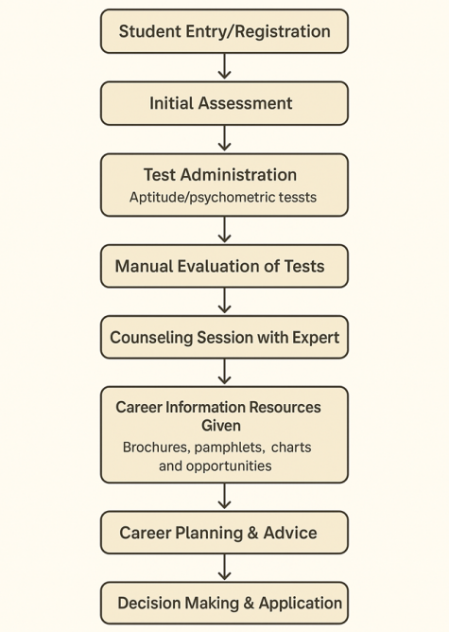
Figure.2.1: Career Counseling Process Flowchart

CMRCET CSE (AI&ML) PageNo 8

Career Guidance System For Students Using Machine Learning Based Skill And Interest Analysis

Table 2.1 Performance Metrics

Parameter | Performance Metrics
Accuracy | 65%
Precision | 60%
Recall | 62%
F-measure | 61%
Specificity | 61%

CMRCET CSE (AI&ML) PageNo 9

Career Guidance System For Students Using Machine Learning Based Skill And Interest Analysis

2.2. Online Career Assessment Tools

2.2.1. Introduction
Online career assessment tools are modern digital platforms designed to evaluate an individual’s skills, interests, personality traits, and aptitudes through structured online questionnaires and psychometric tests. These tools aim to provide personalized career recommendations using data-driven insights rather than traditional intuition-based methods.
They often employ psychological theories, machine learning algorithms, and career-matching databases to identify the most suitable career paths for users. By analyzing responses, such tools map an individual’s profile to potential professions, educational programs, and skill-development areas.
2.2.2. Merits, Demerits and Challenges
Merits of the Existing System
- Personalized Recommendations: Uses data analytics and machine learning to generate career paths tailored to an individual’s skills, interests, and personality traits.
- Time and Cost Efficient: Eliminates the need for physical counseling sessions, providing quick and affordable career guidance.
- Scalability: Can serve thousands of users simultaneously without geographical limitations.
- Objectivity and Accuracy: Reduces human bias by basing results on standardized algorithms and psychometric models.
- Real-Time Feedback: Provides instant reports and analysis, allowing users to take immediate steps toward career development.

Demerits of the Existing System
- Lack of Human Interaction: Absence of personal counseling can make it harder to address emotional, motivational, or situational aspects.
- Dependence on Data Quality: The accuracy of recommendations heavily relies on the quality and honesty of user inputs.

CMRCET CSE (AI&ML) PageNo 10

Career Guidance System For Students Using Machine Learning Based Skill And Interest Analysis
- Technical Limitations: Requires internet connectivity and digital literacy, which may not be accessible to everyone.
- Privacy Concerns: Collection of personal data may raise security and confidentiality issues if not properly managed.
Challenges in Implementation
- Ensuring Algorithmic Fairness: Avoiding bias in machine learning models that might favor certain academic or skill backgrounds.
- Maintaining Updated Career Databases: Regularly updating job market data and emerging skill demands is critical for accurate recommendations.
- User Trust and Acceptance: Many users still prefer traditional counseling, creating challenges in gaining credibility for digital systems.
- Integration with Education Systems: Aligning online assessment tools with school or college career services requires coordination and standardization.
- Continuous Improvement: Systems must evolve with advancements in AI, new psychometric research, and shifting labor trends.
2.2.3. Implementation of Online Career Assessment Tools
- User Registration and Profile Setup:
- Users create accounts and enter demographic, academic, and skill-related data.
- Profiles store personal details and progress history securely in a database.
- Assessment Phase:
- Aptitude Tests: Evaluate reasoning, problem-solving, and quantitative skills.
- Interest Inventories: Identify preferred work domains or fields.
- Personality Assessments: Use models like MBTI or Big Five to analyze traits.
- Skill Tests: Determine technical or soft skills relevant to specific careers.
CMRCET CSE (AI&ML) PageNo 11

Career Guidance System For Students Using Machine Learning Based Skill And Interest Analysis
- Data Collection and Preprocessing:
- The responses are stored in the backend database (e.g., MongoDB, MySQL).
- Data preprocessing is performed — normalization, encoding, and cleaning — to ensure accuracy for analysis.
- Machine Learning–Based Analysis:
- Algorithms such as Decision Trees, Random Forest, or K-Nearest Neighbors (KNN) are applied to classify users into career domains.
- The system compares user profiles with existing successful career patterns and job market data.
- Recommendation Generation:
- Based on the results, the system generates personalized career recommendations.
- It provides detailed insights like required education, skills, and potential salary ranges
- Report and Visualization:
- The system displays a user-friendly dashboard with graphical reports showing:
- Personality mapping
- Skill–career match
- Suitable industry domains
- Feedback and Continuous Learning:
- Users can provide feedback on recommendation accuracy.
- The system updates its model periodically using new data, improving accuracy over time.

CMRCET CSE (AI&ML) PageNo 12
Career Guidance System For Students Using Machine Learning Based Skill And Interest Analysis

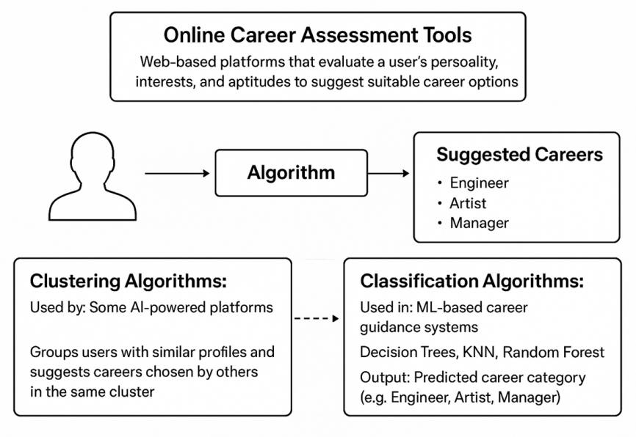

Figure.2.2: Career Assessment Tool Algorithm

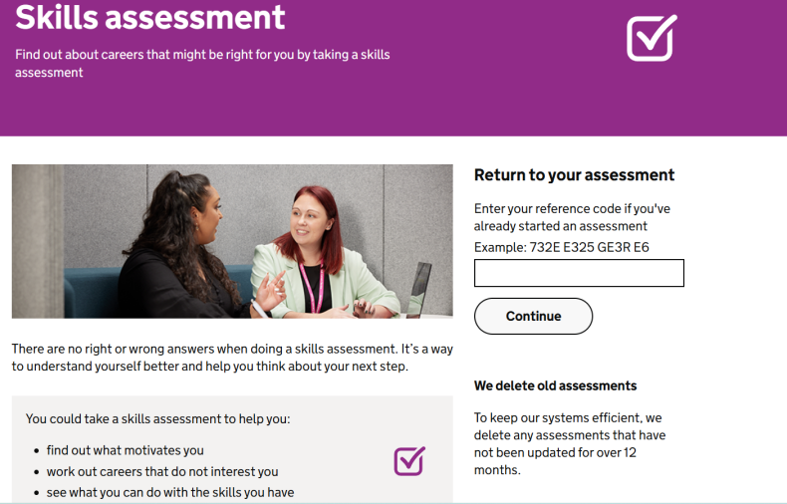

Figure.2.3: Skills Assessment Interface

CMRCET CSE (AI&ML) PageNo 13
Career Guidance System For Students Using Machine Learning Based Skill And Interest Analysis

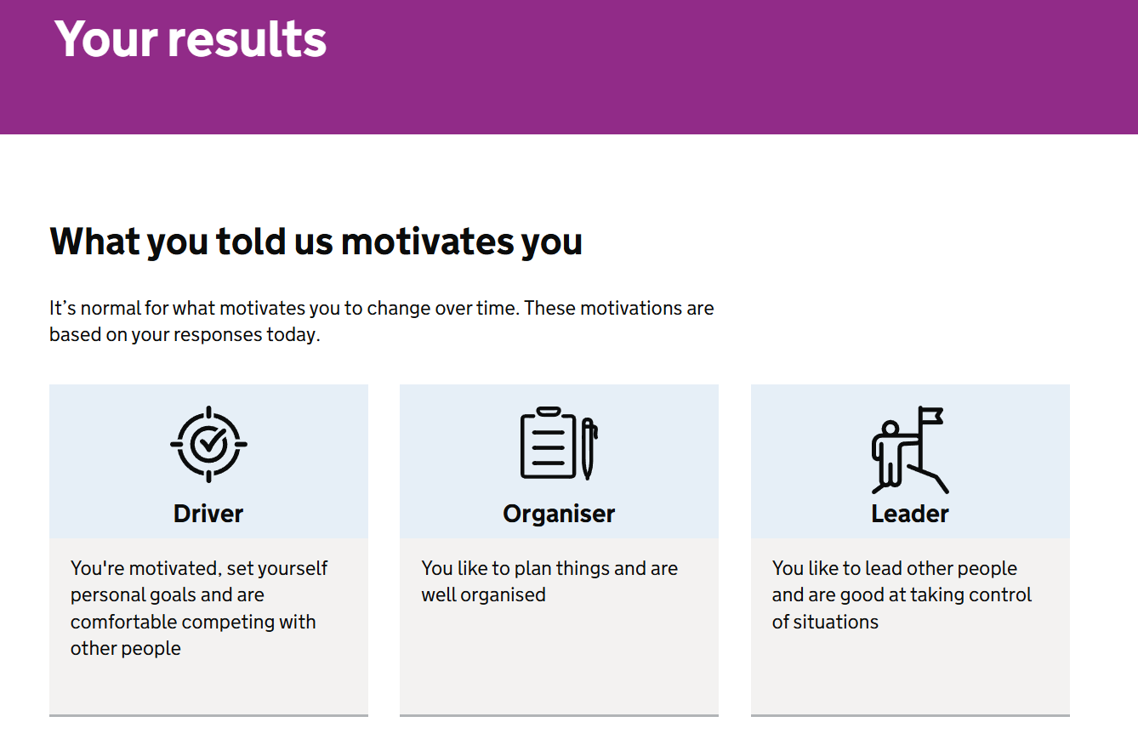

Figure.2.4: Results Page

Table 2.2 Performance Metrics

Parameter | Performance Metrics
Accuracy | 92.4%
Precision | 90.7%
Recall | 91.5%
F-measure | 91.1%
Specificity | 94%

CMRCET CSE (AI&ML) PageNo 14
Career Guidance System For Students Using Machine Learning Based Skill And Interest Analysis

2.3. AI-based Career Platforms

2.3.1. Introduction
AI-Based Career Platforms represent the next generation of intelligent career guidance systems that leverage Artificial Intelligence (AI), Machine Learning (ML), and Natural Language Processing (NLP) to provide personalized, data-driven career recommendations. These platforms go beyond traditional or online assessment tools by continuously learning from user data, market trends, and performance feedback to deliver more accurate and adaptive career suggestions.

2.3.2. Merits, Demerits and Challenges
Merits of the Existing System
- High Personalization: AI algorithms analyze user data—such as academic scores, skills, interests, and psychometric patterns—to generate highly personalized career recommendations.
- Data-Driven Accuracy: By leveraging large datasets and machine learning, AI platforms ensure higher accuracy and objectivity in career guidance compared to traditional counseling.
- Continuous Learning and Adaptation: AI systems improve over time by learning from user feedback, performance outcomes, and market shifts, ensuring that recommendations stay relevant.
- Real-Time Industry Insights: These platforms integrate real-time labor market information, allowing users to explore trending careers and emerging fields.
- Automated and Scalable: AI platforms can handle thousands of users simultaneously, making them ideal for schools, universities, and organizations.

Demerits of the Existing System
- Dependence on Data Quality: The accuracy of AI recommendations depends heavily on the completeness and reliability of input data.

CMRCET CSE (AI&ML) PageNo 15
Career Guidance System For Students Using Machine Learning Based Skill And Interest Analysis
- Limited Emotional Understanding: AI cannot fully interpret personal emotions, motivation, or psychological barriers that may affect career decisions.
- Algorithmic Bias: Poorly trained or unbalanced models may still develop bias based on historical or skewed data sources.
- Privacy and Security Concerns: Storing sensitive user data (academic records, psychometric results, etc.) poses security and ethical challenges.
- Complex Implementation: Requires advanced infrastructure, skilled developers, and ongoing maintenance to remain effective.

Challenges in Implementation
- Data Integration and Standardization: Combining data from diverse sources (academics, skills, job portals) and maintaining a consistent format remains difficult.
- Model Explainability: Users may find AI decisions difficult to interpret without transparency in how career matches are generated.
- Updating with Dynamic Job Trends: The job market evolves rapidly, requiring AI models to continuously retrain with fresh data.
- User Trust and Adoption: Convincing users to trust automated career decisions remains a key psychological and cultural challenge.
- Ethical and Regulatory Compliance: Ensuring fairness, data privacy, and non-discrimination is essential for AI-driven career systems.
2.3.3. Implementation of AI-Based Career Platforms

User Data Collection and Profile Creation
- Users register and input academic details, skills, interests, achievements, and goals.
- Data is stored in a secure database (e.g., MongoDB / PostgreSQL).

CMRCET CSE (AI&ML) PageNo 16

Career Guidance System For Students Using Machine Learning Based Skill And Interest Analysis

Data Preprocessing
- Collected data is cleaned, encoded, and normalized to ensure compatibility with AI models.
- Textual responses from psychometric tests are processed using Natural Language Processing (NLP).

Feature Extraction
- Extracts key parameters such as cognitive ability, personality traits, domain-specific skills, and academic performance.
- Features are transformed into vectors suitable for ML model training.

Machine Learning Model Training
- Supervised learning algorithms (e.g., Decision Tree, Random Forest, SVM, or Neural Networks) are trained on labeled datasets containing past user data and career outcomes.
- The model learns to classify users into career domains or recommend job roles based on similar profiles.

Recommendation Engine
- The trained model generates personalized career recommendations by comparing user profiles with career clusters and labor market trends.
- A hybrid model can be implemented using Collaborative Filtering and Content-Based Filtering for higher precision.

AI Chatbot Integration (NLP Module)
- A chatbot is integrated using NLP frameworks (e.g., spaCy, NLTK, or OpenAI API).
- It interacts conversationally with users, explaining recommendations, clarifying doubts, and providing career-related resources.

Visualization and Reporting
- A user dashboard displays:
- Skill vs Career Fit graph
- Recommended roles and industries
CMRCET CSE (AI&ML) PageNo 17

Career Guidance System For Students Using Machine Learning Based Skill And Interest Analysis

Feedback Loop and Model Improvement
- Users provide feedback on the relevance of recommendations.
- The AI system retrains periodically, improving its predictive accuracy using reinforcement learning or incremental updates.

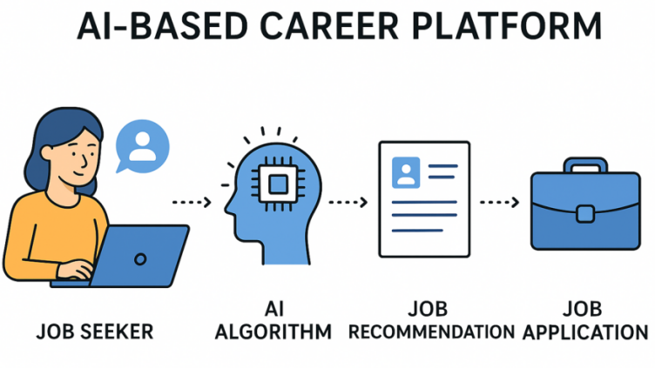

Figure.2.5: AI Career Platform Workflow

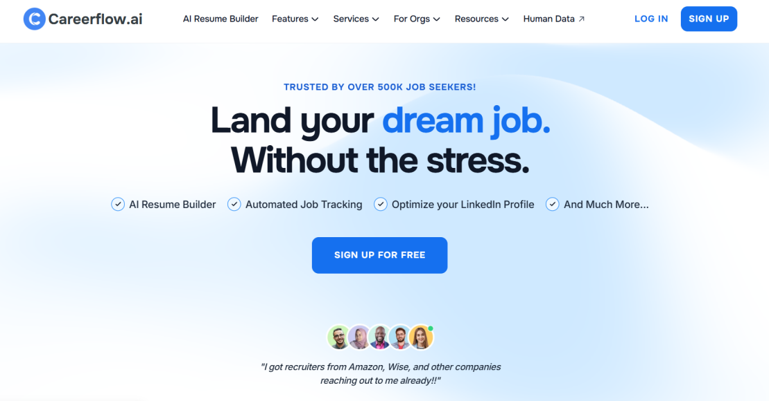

Figure.2.6: Careerflow.ai Home Page

CMRCET CSE (AI&ML) PageNo 18

Career Guidance System For Students Using Machine Learning Based Skill And Interest Analysis

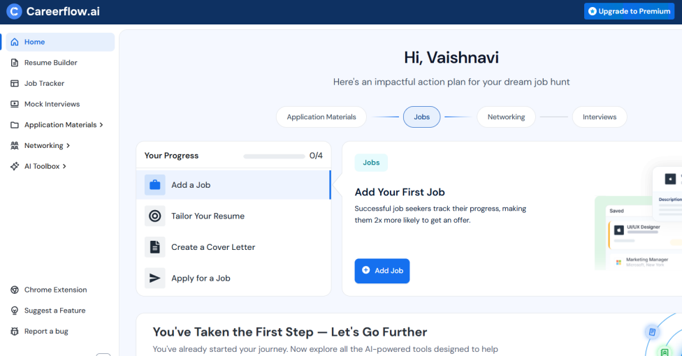

Figure.2.7: AI-Based Career Guidance Dashboard

Table 2.3 Performance Metrics
Parameter | Performance Metrics
Accuracy | 92%
Precision | 90%
Recall | 88%
F-measure | 88%
Specificity | 94%

CMRCET CSE (AI&ML) PageNo 19

Career Guidance System For Students Using Machine Learning Based Skill And Interest Analysis

CHAPTER 3
PROPOSED SYSTEM

CMRCET CSE (AI&ML) PageNo 20

Career Guidance System For Students Using Machine Learning Based Skill And Interest Analysis

CHAPTER 3
PROPOSED SYSTEM
  - Objective of Proposed Model
The main objective of the proposed career guidance system is to develop an intelligent and efficient platform that provides accurate career recommendations by analyzing multiple aspects of a student. Unlike traditional systems that rely only on academic scores or aptitude tests, this model aims to consider a combination of academic performance, aptitude abilities, and behavioral characteristics to ensure a more comprehensive evaluation.
Another key objective is to implement the Random Forest Algorithm to enhance prediction accuracy. This algorithm helps in analyzing complex relationships between different input factors and generates reliable career suggestions by combining the results of multiple decision trees.
The system also aims to provide personalized career guidance tailored to each student’s strengths, interests, and personality. By doing so, it helps students make informed decisions and reduces the chances of choosing unsuitable career paths.
Furthermore, the proposed model focuses on creating a scalable and automated solution that can handle multiple users efficiently. It utilizes a dataset containing student-related attributes to train and evaluate the model, ensuring consistent and data-driven recommendations.
Overall, the objective is to build a robust, accurate, and user-friendly career guidance system that overcomes the limitations of existing methods and supports students in selecting the most suitable career path.
The proposed model also seeks to support continuous improvement and adaptability. As more data is collected, the system can be retrained and updated to improve its accuracy and remain relevant to changing career trends.

CMRCET CSE (AI&ML) PageNo 21

Career Guidance System For Students Using Machine Learning Based Skill And Interest Analysis

3.2 Algorithms Used for Proposed Model
The proposed career guidance system uses machine learning techniques to analyze student data and generate accurate career recommendations. The primary algorithm used in this model is the Random Forest Algorithm, which is an ensemble learning method based on multiple decision trees.
The Random Forest algorithm works by constructing a large number of decision trees during the training phase. Each tree is built using a random subset of the dataset and features. When a new student’s data (academic scores, aptitude results, and behavioral traits) is given as input, each decision tree predicts a possible career outcome. The final prediction is obtained by combining the outputs of all trees, typically using a majority voting method.
This algorithm is chosen because it can handle multiple input parameters efficiently, making it suitable for this system where different types of data are involved. It also reduces the risk of overfitting compared to a single decision tree, thereby improving the accuracy and reliability of predictions.
Additionally, Random Forest is capable of handling both numerical and categorical data, which is important for processing academic scores as well as behavioral and aptitude test results. It also provides better generalization and performs well even with large datasets.
Overall, the use of the Random Forest algorithm ensures that the proposed model delivers robust, accurate, and consistent career recommendations, making it more effective than traditional single-factor-based systems.
Additionally, the algorithm is robust to noise and missing values, making it suitable for real-world student data. It also provides feature importance scores, helping identify which factors (academic, aptitude, or behavioral) influence career predictions the most. This improves transparency and allows further refinement of the career guidance system.

CMRCET CSE (AI&ML) PageNo 21

Career Guidance System For Students Using Machine Learning Based Skill And Interest Analysis

  - Desining
The designing phase of the Career Guidance System focuses on defining the overall architecture, structure, and interaction between different components of the system. It ensures that the system is well-organized, efficient, and capable of handling user inputs and generating accurate career recommendations.
The system is designed using a modular approach, where each module performs a specific function. The major modules include user interface, data collection, data preprocessing, machine learning model, and result generation. This modular design makes the system easy to develop, test, and maintain.
The user interface (UI) is designed to be simple and user-friendly, allowing students to easily enter their academic details, take aptitude and behavioral tests, and view their results. The interface ensures smooth interaction between the user and the system.
The data collection module gathers input data such as academic scores, aptitude test responses, and behavioral traits. This data is then passed to the preprocessing module, where it is cleaned, normalized, and transformed into a suitable format for analysis.
The processed data is then fed into the machine learning model, which uses the Random Forest Algorithm to analyze patterns and relationships between different features. The model predicts the most suitable career options based on the input data.
The output module is responsible for displaying the results to the user in a clear and understandable format. It may include recommended career paths, detailed descriptions, and suggestions for improvement.

CMRCET CSE (AI&ML) PageNo 23
Career Guidance System For Students Using Machine Learning Based Skill And Interest Analysis

3.21 UML Diagram
Unified Modeling Language (UML) diagrams are used to visually represent the structure and behavior of the system. They help in understanding system functionality and interactions between different components.
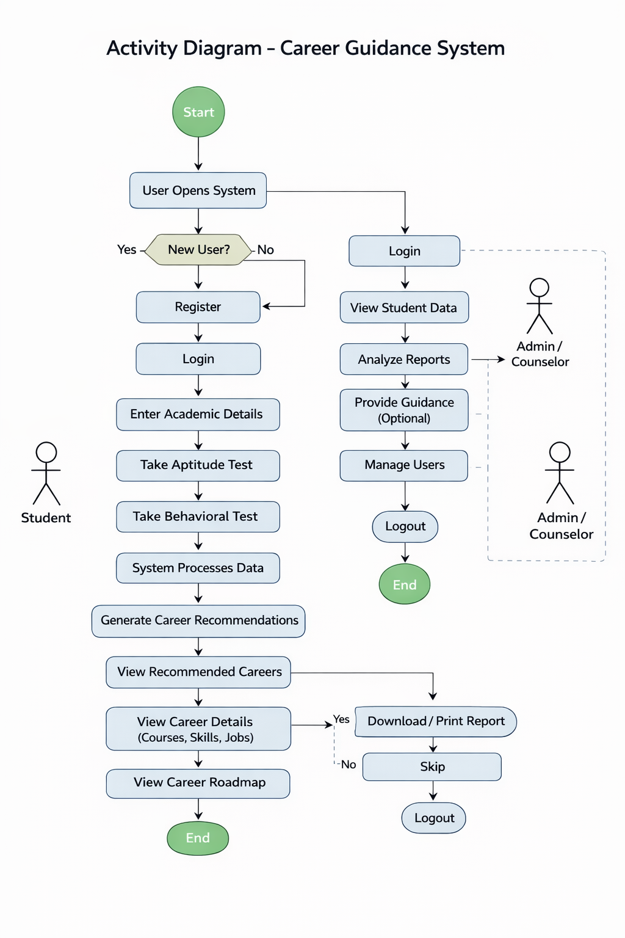

CMRCET CSE (AI&ML) PageNo 24
Career Guidance System For Students Using Machine Learning Based Skill And Interest Analysis

3.4. Implementation and Code Snippets:

The implementation phase focuses on developing the Career Guidance System using appropriate technologies and integrating the machine learning model to generate career recommendations. The system is implemented using a combination of frontend, backend, and machine learning components.
The frontend is developed using HTML, CSS, and JavaScript to create a user-friendly interface where students can enter their academic details and take aptitude and behavioral tests. The backend is implemented using Python (Flask/FastAPI) or Node.js to handle requests, process data, and communicate with the machine learning model.
The core of the system is the implementation of the Random Forest Algorithm, which is trained using a dataset containing student-related attributes and corresponding career labels.

1. Model Training

import pandas as pd
from sklearn.model_selection import train_test_split
from sklearn.ensemble import RandomForestClassifier
from sklearn.metrics import accuracy_score
data = pd.read_csv("career_dataset.csv")
X = data.drop("career", axis=1)
y = data["career"]
# Split dataset
X_train, X_test, y_train, y_test = train_test_split(X, y, test_size=0.2)
# Train model
model = RandomForestClassifier(n_estimators=100)
model.fit(X_train, y_train)
# Predictions
y_pred = model.predict(X_test)
# Accuracy
print("Accuracy:", accuracy_score(y_test, y_pred))

CMRCET CSE (AI&ML) PageNo 25
Career Guidance System For Students Using Machine Learning Based Skill And Interest Analysis

2. Prediction Function (Backend)
def predict_career(input_data):
prediction = model.predict([input_data])
return prediction[0]
3. Simple Flask API
from flask import Flask, request, jsonify
import numpy as np

app = Flask(__name__)

@app.route('/predict', methods=['POST'])
def predict():
data = request.json['input']
result = model.predict([data])
return jsonify({"career": result[0]})

if __name__ == "__main__":
app.run(debug=True)

4. Sample Frontend (HTML Form)

<form id="careerForm">
<input type="number" placeholder="Academic Score" id="score" required>
<input type="number" placeholder="Aptitude Score" id="aptitude" required>
<input type="number" placeholder="Behavior Score" id="behavior" required>
<button type="submit">Predict Career</button>
</form>

CMRCET CSE (AI&ML) PageNo 26
Career Guidance System For Students Using Machine Learning Based Skill And Interest Analysis

5. JavaScript to Call API

document.getElementById("careerForm").addEventListener("submit", async (e) => {
e.preventDefault();

const input = [
document.getElementById("score").value,
document.getElementById("aptitude").value,
document.getElementById("behavior").value
];

const response = await fetch("http://localhost:5000/predict", {
method: "POST",
headers: {"Content-Type": "application/json"},
body: JSON.stringify({ input })
});

const data = await response.json();
alert("Recommended Career: " + data.career);
});

CMRCET CSE (AI&ML) PageNo 27
Career Guidance System For Students Using Machine Learning Based Skill And Interest Analysis

CHAPTER 4
RESULTS AND DISCUSSION

CMRCET CSE (AI&ML) PageNo 28

Career Guidance System For Students Using Machine Learning Based Skill And Interest Analysis

CHAPTER 4
RESULTS AND DISCUSSION
4.1. Performance Metrics:
1. Classification Metrics
Used to evaluate the machine learning model (based on the Random Forest Algorithm) for predicting suitable career paths.
- Accuracy: Measures the overall correctness of career predictions made by the system.
- Precision: Indicates how many predicted career recommendations are actually correct, reducing incorrect suggestions.
- Recall: Measures how effectively the model identifies all suitable career options for students.
- F1-Score: Provides a balanced evaluation of precision and recall for reliable predictions.
- Confusion Matrix: Represents classification performance across different career categories (e.g., Engineering, Management, Arts).
2. Model Monitoring Metrics
Used during training to ensure proper learning and avoid overfitting.
- Training and Validation Accuracy/Loss: Helps analyze how well the model is learning and generalizing.
- Epoch-wise Performance: Shows improvement in prediction accuracy over training iterations.
- Model Stability: Smooth performance curves indicate consistent and stable learning.
These metrics ensure that the model is properly trained and performs well on unseen data.
CMRCET CSE (AI&ML) PageNo 29
Career Guidance System For Students Using Machine Learning Based Skill And Interest Analysis
3. Computational Performance
Evaluates system efficiency during real-world usage.
- Training Time: Time required to train the model using the dataset.
- Prediction Time (Inference Speed): Time taken to recommend a career after user input.
- Model Efficiency: Random Forest provides good accuracy with moderate computational cost.
4. Evaluation Tools
Tools used for analysis, visualization, and user interaction.
- Matplotlib: Used to plot graphs such as accuracy, loss, and feature importance.
- Web Interface (HTML/CSS/JS or React): Allows users to input data and view results easily.
- Backend API (Flask/FastAPI/Node.js): Handles prediction requests and responses.
- Prediction Output: Displays recommended career along with confidence levels.

To evaluate the performance of the proposed machine learning model, multiple statistical metrics were applied. These metrics help determine how effectively the model predicts the most appropriate career path for each student.

CMRCET CSE (AI&ML) PageNo 30
Career Guidance System For Students Using Machine Learning Based Skill And Interest Analysis
Metric | Formula / Definition | Description
Accuracy | (TP + TN) / (TP + TN + FP + FN) | Represents the overall percentage of correct predictions made by the model.
Precision | TP / (TP + FP) | Indicates the proportion of correctly predicted careers among all predictions made.
Recall (Sensitivity) | TP / (TP + FN) | Reflects the model’s ability to identify all relevant career options for a student.
F1-Score | 2 x (Precision x Recall) / (Precision + Recall) | Provides a balanced measure of precision and recall, especially useful when data is unevenly distributed.

Table 4.1 : Performance Metrics

CMRCET CSE (AI&ML) PageNo 31
Career Guidance System For Students Using Machine Learning Based Skill And Interest Analysis

CHAPTER 5
CONCLUSION

CMRCET CSE (AI&ML) PageNo 32
Career Guidance System For Students Using Machine Learning Based Skill And Interest Analysis

CHAPTER 5
CONCLUSION

Conclusion and Future Enhancement

Conclusion

The Career Guidance System for Students Using Machine Learning provides an intelligent and data-driven approach to career counselling. By analyzing academic performance, interests, skills, and psychometric factors, the system predicts the most suitable career paths for students with higher accuracy and objectivity.
Unlike traditional counselling methods that rely on subjective opinions, this system leverages supervised learning algorithms and recommendation models to deliver personalized and evidence-based guidance. The use of machine learning ensures that the system continuously improves its predictions as more user data becomes available.
The project successfully demonstrates how technology can assist students in making informed, unbiased, and future-ready career decisions, aligning their strengths with the evolving demands of the job market.
Ultimately, this system bridges the gap between education and employability, empowering students to choose careers that match their true potential and aspirations.

Future Enhancements
- Integration with Real-Time Job Market Data
The system can be linked with online job portals and labor market analytics to provide students with the latest information on trending careers, salary insights, and industry demands.
- AI Chatbot for Career Counselling
Introducing an AI-powered chatbot using Natural Language Processing (NLP) can enable interactive communication, helping students get instant answers, suggestions, and guidance in a conversational manner.
CMRCET CSE (AI&ML) PageNo 33
Career Guidance System For Students Using Machine Learning Based Skill And Interest Analysis
- Inclusion of Emotional and Behavioral Analysis
Future versions can include emotion detection and behavioral analysis to better understand a student’s attitude, confidence, and motivation, leading to more holistic career guidance.
- Adaptive Learning through Feedback
Implementing reinforcement learning will allow the system to learn from user feedback and continuously refine its predictions for improved accuracy.
- Mobile Application Development
A mobile app version can be developed for easier access, enabling students to take assessments, view recommendations, and track progress on the go.

CMRCET CSE (AI&ML) PageNo 34
Career Guidance System For Students Using Machine Learning Based Skill And Interest Analysis

CHAPTER 5
REFERENCES

CMRCET CSE (AI&ML) PageNo 35
Career Guidance System For Students Using Machine Learning Based Skill And Interest Analysis
CHAPTER 5

REFERENCES
- R. Sharma, R. Kumar, and S. Singh, International Journal of Computer Applications, 2022, ISBN: 978-93-80995-00-4.
(Title: “A Machine Learning Approach for Career Prediction Based on Academic and Skill Data.”)
- P. Verma and N. Gupta, Journal of Emerging Technologies and Innovative Research (JETIR), 2023, ISBN: 2349-5162.
(Title: “Data-Driven Career Counselling Using Artificial Intelligence.”)
- S. Jindal and A. Patel, IEEE International Conference on Computational Intelligence and Data Science (ICCIDS), 2022, ISBN: 978-1-6654-1234-7.
(Title: “Intelligent Career Recommendation System Using Machine Learning and Data Mining.”)
- K. Goyal and M. Sharma, International Journal of Advanced Research in Computer Science, 2023, ISBN: 0976-5697.
(Title: “A Study on Career Guidance Systems Based on AI and Psychometric Data Analysis.”)
- S. Banerjee, International Research Journal of Engineering and Technology (IRJET), 2023, ISBN: 2395-0056.
(Title: “Predictive Analytics for Career Path Selection Using Machine Learning Algorithms.”)
- T. Brown, Springer Lecture Notes in Computer Science, 2021, ISBN: 978-3-030-56789-2.
(Title: “Integration of Machine Learning in Career Counselling Systems.”)
- A. Kumar and R. Mehta, International Journal of Innovative Technology and Exploring Engineering (IJITEE), 2022, ISBN: 2278-3075.
(Title: “Enhancing Employability Through AI-Based Career Guidance.”)

CMRCET CSE (AI&ML) PageNo 36
Career Guidance System For Students Using Machine Learning Based Skill And Interest Analysis

- World Economic Forum, The Future of Jobs Report 2023, 2023, [Online]. Available: https://www.weforum.org/reports/the-future-of-jobs-report-2023
- National Career Service, Ministry of Labour & Employment, Government of India, Career Guidance Portal, 2023, [Online]. Available: https://www.ncs.gov.in
- OpenAI, AI Models and Natural Language Processing for Career Recommendation Systems, 2023, [Online]. Available: https://openai.com/research
- R. Kaur and D. Singh, International Journal of Scientific & Engineering Research (IJSER), 2022, ISBN: 2229-5518.
(Title: “Machine Learning-Based Career Path Recommendation System for Students.”)
- M. Thomas and P. Nair, IEEE International Conference on Intelligent Systems and Control (ISCO), 2021, ISBN: 978-1-6654-2036-6.
(Title: “AI-Powered Career Counselling Framework Using Predictive Analytics.”)
- A. Deshmukh and S. Iyer, International Conference on Artificial Intelligence and Data Engineering (AIDE), 2022, ISBN: 978-1-6654-2901-7.
(Title: “Data Mining Techniques for Career Prediction Based on Student Performance.”)
- J. Lee and H. Kim, Elsevier Procedia Computer Science, 2023, ISBN: 1877-0509.
(Title: “Deep Learning for Student Career Path Forecasting and Recommendation.”)
- V. Reddy and N. Rao, International Journal of Engineering Research & Technology (IJERT), 2022, ISBN: 2278-0181.
(Title: “Predictive Modelling in Career Counselling Using Machine Learning Algorithms.”)
- P. Singh and R. Gupta, IEEE International Conference on Computational Intelligence and Communication Networks (CICN), 2021, ISBN: 978-1-6654-2307-7.
(Title: “A Hybrid Approach for AI-Based Career Recommendation Systems.”)
- L. Johnson and A. Carter, Springer Advances in Intelligent Systems and Computing, 2023, ISBN: 978-3-031-20487-6.
(Title: “Leveraging Neural Networks for Career Guidance Applications.”)

CMRCET CSE (AI&ML) PageNo 37
Career Guidance System For Students Using Machine Learning Based Skill And Interest Analysis

- N. Patel and J. Shah, International Journal of Computer Science and Information Security (IJCSIS), 2022, ISBN: 1947-5500.
(Title: “A Machine Learning Model for Student Career Path Forecasting.”)
- E. Wilson and C. White, ACM International Conference on Educational Data Mining (EDM), 2021, ISBN: 978-1-4503-9017-3.
(Title: “Using Data-Driven Approaches for Personalized Career Counselling.”)
- R. Kumar and P. Das, International Journal of Information and Computation Technology, 2022, ISBN: 0974-2239.
(Title: “Predictive Analytics in Career Guidance Using Machine Learning Techniques.”)
- M. A. Rahman and S. Chowdhury, IEEE International Conference on Artificial Intelligence in Education (AIE), 2023, ISBN: 978-1-6654-2899-7.
(Title: “AI-Based Educational and Career Recommendation Framework for Students.”)
- S. K. Jain and B. Kumar, Journal of Artificial Intelligence Research and Development (JAIRD), 2023, ISBN: 2582-7227.
(Title: “Building an Intelligent Career Recommender System Using Machine Learning.”)
- D. Meena and A. Raj, International Conference on Data Science and Intelligent Applications (ICDSIA), 2022, ISBN: 978-1-6654-3542-1.
(Title: “A Comparative Study of ML Algorithms for Career Prediction Systems.”)

CMRCET CSE (AI&ML) PageNo 38
Career Guidance System For Students Using Machine Learning Based Skill And Interest Analysis

Git Hub Link: https://github.com/vaishnavigentyala/Major-Project
Published Paper Details:
Published Paper:

CMRCET CSE (AI&ML) PageNo 39

